Huilongguan Street
Baltimore, Newstreet 322021
(202)555-7589
June 6,2015
Mr.paul
BUPT Universuty
LABORATORY REPORT
Wheaststone Bridge
INTRODUCTORY SUMMARY&PURPOSE

1 Grasp the measuring method of the amplifying circuit
2. Grasp the concept of Wheaststone Bridge

EXPERIMENT EQUIPMENT
- Digital multitester
- DC stabilized voltage power supply.
- Current detector
- Resistance box
- 3V-Dry cell

PREPARATION REQUIREMENTS
a.preview the measuring Principle and characteristics of the Wheaststone Bridge.
b.Preview the principle of decreasing the measurement error using exchange method.

LAB PROCEDURE
Step1:Measure the resistances of two unknown resisitors utilizing the Wheaststone Bridge.

1.Set up the Wheaststone Bridge.

2.Measure the precise resistance value of 200Ω,Fix the slider at the center of the slide rheostat

3.Exchange the positions between the resistor.

Step2:Measure the sensitivity of the Wheaststone Bridge.

1.Balance the bridge by varying the resistance of the Rs.

2.Change a minute resistance △Rs for the resistor Rs slowly and make the pointer deviate from the equilibrium value of the galvanometer with a variation △n.

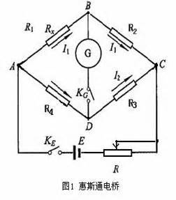
PROBLEMS ENCOUNTERED
The errors form resistance precision and operation zero draft, zero temperature .From the begining , error is small when the voltage is added to 3V, measurement value are not similar because of the amplifier itself.uct various mathemat.

CONCLUSION
Through this experiment, to understand the principle of the wheatstone bridge, familiar with the connection. Experiments go smoothly. The result processing accurately, the range of allowable error in, before and after the experiment the instruments are good.

Sincerely,
Chenyu Pang

